Build a simple Task Application

STEP 1: Create a interface to accept card name from user.
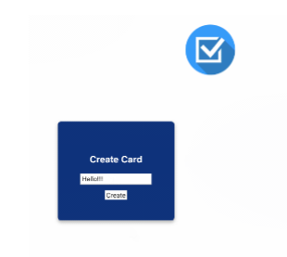

STEP 2:Like shown below user can create multiple cards.
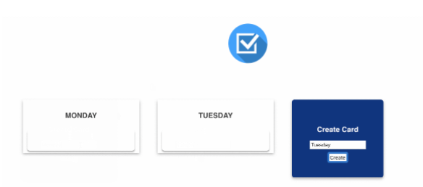
STEP 3: Inside each card user can create multiple task.

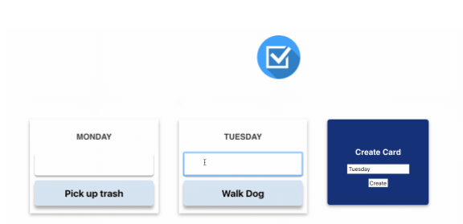
STEP 4:Finally after a task is over the user will click on the task to srike it out
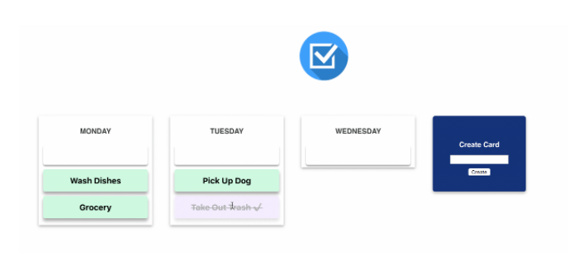

Note: Store the values in a Database of your choice.

